

John Blandy
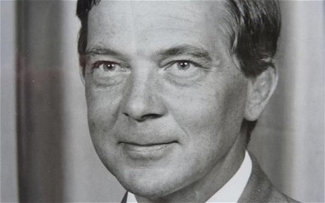
John Blandy, who died on July 23 aged 83, was one of the outstanding urologists of his generation.

6:37PM BST 25 Aug 2011

Not only a surgeon of great ability, Blandy was also a caring physician and a fine teacher. Because of his excellent written English — a rarity in the medical world — he was able to communicate to a wide audience both nationally and internationally.

John Peter Blandy was born in Calcutta on September 11 1927, the son of Sir Nicolas Blandy, Senior Colonial Administrator in Bengal. After attending a prep school in the hills near Darjeeling, he was sent to Clifton, where he excelled in biology and developed his talent for drawing and painting. He read Medicine at Balliol College, Oxford, then studied at the London Hospital before electing to become a surgeon.

After National Service with the RAMC, Blandy had a spell at King George’s, Ilford, then returned to the London to work in thoracic and general surgery. In 1959 he won a Robertson Fellowship to the Presbyterian St Luke’s Hospital in Chicago.

His project there was to look into the practicalities of bladder replacements, the initial idea coming from his friend and future colleague Richard Turner-Warwick. His work was laboratory-based and provided the basis for two scientific papers and most of the work towards his DM (Oxford) thesis.

In 1962 he returned to Britain to take up a post as lecturer on the London Hospital’s surgical unit, and spent the next year as residential surgical officer at St Paul’s Hospital in London, one of the three specialist urological hospitals at that time. In 1964 he was appointed consultant surgeon at the London on the retirement of Victor Dix.

Initially responsible for some general surgical emergencies, Blandy soon established a national reputation as a urologist. He popularised transurethral resection of the prostate in Britain (to treat enlarged prostates), teaching by demonstration and producing an excellent textbook on the subject.

Working closely with Harold Hope-Stone, he also developed an expertise in testicular cancer while at the same time learning the then-new technique of renal transplantation from Ken Owen at St Mary’s Hospital and Roy Calne at Cambridge. Because of the dependence of transplantation on immunological research, Blandy was brought into contact with Hilliard Festenstein, a highly imaginative immunologist who had fled from South Africa, being a strong supporter of Nelson Mandela and the ANC. Blandy encouraged Festenstein to come to the London, where they worked together.

At the same time Blandy was developing a private practice in Harley Street. In 1969 he was appointed Professor of Urology at the London (the first departmental chair in urology in the capital). The previous year he had been appointed to the staff at St Peter’s Hospital, London, the world’s oldest urological hospital.

Over the next two decades Blandy’s urological interests included transplantation, renal stone disease, benign prostatic disease, and bladder and testicular cancer. He also worked on treatments for male infertility and the narrowing of the urethra, describing a new operative technique for the latter problem.

His many books became standard texts throughout the world, and Blandy travelled widely, while continuing to fulfil his heavy clinical workload at the London and St Peter’s, where he trained several generations of urologists .

Blandy was elected to the council of the Royal College of Surgeons of England in 1982 (he was vice-president from 1992 to 1994) and became President of BAUS (British Association of Urological Surgeons) in 1984. He was also president of the European Association of Urology (EAU) in 1986. He received many honours and awards, and in 1995 was appointed CBE.

After retiring from clinical practice in 1992, Blandy remained active in his field. But he also found time to pursue his interest in painting and sculpting. He exhibited jointly with his daughter Kitty, a professional sculptor and artist.

John Blandy married, in 1953, Anne Mathias, who survives him with their four daughters.

