Global Surgery: A 30-year Bibliometric Analysis (1987-2017)

Alessandro Sgrò^{1,*}, Ibrahim S Al-Busaidi^{2,*}, Cameron I Wells^{3,*}, Dominique Vervoort⁴, Sara Venturini⁵, Valeria Farina⁶, Federica Figà⁷, Francesc Azkarate⁸, Ewen M Harrison⁹, Francesco Pata¹⁰.

1 Faculty of Medicine, University of Pavia, Pavia, Italy.
2 Department of Medicine, Christchurch Hospital, University of Otago, Christchurch, New Zealand.
3 Department of Surgery, Faculty of Medical and Health Sciences, The University of Auckland, Auckland, New Zealand.
4 Program in Global Surgery and Social Change, Department of Global Health and Social Medicine, Harvard Medical School, Boston, MA, USA.
5 Aberdeen Royal Infirmary, NHS Grampian, Foresterhill Health Campus, Foresterhill Road, Aberdeen, UK.
6 Città della Salute e della Scienza, Molinette, Turin, Italy.
7 Faculty of Medicine, Department of Precision Medicine, Università degli Studi della Campania ‘Luigi Vanvitelli’, Naples, Italy.
8 Faculty of Medicine, Universitat Pompeu Fabra (UPF), Barcelona, Spain.
9 Department of Clinical Surgery, The University of Edinburgh, Edinburgh, EH16 4SA, UK.
10 General Surgery Unit, Nicola Giannettasio Hospital, Corigliano-Rossano, Italy.

* Joint first authors

Corresponding author: Ibrahim S Al-Busaidi, Clinical Lecturer (Honorary), Department of Medicine, Christchurch Hospital, University of Otago, Christchurch, New Zealand. E-mail: ibrahim.al-busaidi@cdhb.health.nz

Key words: Bibliometric analysis; Global surgery; Biomedical research; Surgical procedures.

Running title: Global Surgery (1987-2017)

Conflicts of Interest:
The authors have no conflicts of interest to declare.

Funding:
This work was unfunded.

Acknowledgements:
None.

Availability of data and materials:
All data used in this article can be found on the Scopus® database using the search strategy outlined in the Methods section. A complete list of all included papers in available upon reasonable request.

Abstract word count: 249
Manuscript word count: 2368
Abstract

Introduction: There has been growing interest in addressing the surgical disease burden in low- and middle-income countries (LMICs). Assessing the current state of global surgery research activity is an important step in identifying gaps in knowledge and directing research efforts towards important unaddressed issues. The aim of this bibliometric analysis was to identify trends in the publication of global surgical research over the last 30 years.

Methods: Scopus® was searched for global surgical publications (1987-2017). Results were hand-screened and data collected for included articles. Bibliometric data were extracted from Scopus® and Journal Citation Reports. Country-level economic and population data were obtained from the World Bank. Descriptive statistics were used to summarise data and identify significant trends.

Results: A total of 1,623 articles were identified. The volume of scientific production on global surgery increased from 14 publications in 1987 to 149 in 2017. Similarly, the number of articles published open access increased from four in 1987 to 68 in 2017. Observational studies accounted for 88.7% of the included studies. The three most common specialties were obstetrics and gynaecology 260 (16.0%), general surgery 256 (15.8%) and paediatric surgery 196 (12.1%). Over two times as many authors were affiliated to an LMIC institution than to a high-income country (HIC) institution (6628, 71.5% vs 2481, 28.5%, P<0.001). 965 studies (59.5%) were conducted entirely by LMIC authors, 534 (32.9%) by collaborations between HICs and LMICs.

Conclusion: The quantity of research in global surgery has substantially increased over the past 30 years. Authors from LMICs seemed the most proactive in addressing the global surgical disease burden. Increasing the funding for interventional studies, and therefore the quality of evidence in surgery, has the potential for greater impact for patients in LMICs.
Introduction

Global surgery is defined as an area of study, research, practice, and advocacy within global health that seeks to improve health outcomes and achieve health equity for all people who need surgical and anaesthesia care, with a special emphasis on low- and middle-income countries (LMICs) (1). The Lancet Commission on Global Surgery estimated that approximately five billion people around the world do not have adequate, timely access to safe surgical, obstetric and anaesthesia care (2). Moreover, the disparity in surgical care is stark, with the poorest third of the world receiving only 3-6% of operations and the richest third almost 75%. Lack of surgical care is responsible for approximately 18 million preventable deaths and 77 million disability-adjusted life years (DALYs) lost every year, greater than HIV/AIDS, malaria and tuberculosis combined, with most of the preventable deaths due to non-compressible bleeding and lack of access to emergency surgery (3). To match the surgical demand of LMICs by 2030 and prevent a potential loss of 12.3 trillion dollars of economic growth by LMICs, 2.2 million more surgeons, anaesthetists, and obstetricians, plus an investment of $350 billion dollars, are needed, with the goal to raise the operative volume of countries to 5,000 per 100,000 population, equalling an increase of 143 million more surgical procedures per year (1).

In recent years, many surgeons, residents, and medical students have expressed a growing interest in helping to address the global surgical disease burden. This has been reflected in the growth of global surgery committees in surgical societies (4), a growing number of university-based centres focused on global surgery (5), the emergence of global surgery publications in major journals (6) and the accreditation of global elective rotations by the Accreditation Council for Graduate Medical Education (7).

The quantitative and qualitative assessment of the published literature is known as bibliometrics (8). Bibliometric indicators have become an important part of modern assessment of academic productivity, including readiness for promotions and other awards, since results from bibliometric analyses can be a critically important source of objective information about the quantity (publication output, areas of research focus, and trends over time) and quality (level of evidence, impact factor, and citation rates) of scientific work. Exploring these trends is crucial for identifying gaps in knowledge in the field of global surgery, directing research efforts towards important unaddressed issues, and supporting policies geared towards promoting health outcomes in LMICs (8). Bibliometric studies have played a fundamental role in understanding research status and knowledge gaps in many biomedical fields including infectious diseases (9), cardiovascular disease (10), and cancer (11).

To our knowledge, a bibliometric analysis of global surgery research output has never been carried out. The primary aims of this study were to provide an in-depth evaluation of the profile of global surgery literature and to examine trends in global surgery research using large-scale data analysis and commonly employed bibliometric indicators of production, quality and quantity (12).
Methods and materials
Before performing the literature search, the steps of the study were planned and written in a protocol. The contents of the protocol are outlined below.

Data Source
A bibliometric analysis of scientific publications from 1987 to 2017 on global surgery was conducted using the Scopus® database (Elsevier, Amsterdam, Netherlands) on March 24th 2018. Scopus® is a widely used database for bibliometric analyses and often preferred owning to the wider journal range, augmented citation analysis, and availability of several bibliometric indicators (e.g., Hirsh-index (H-index)) (13). The literature search was limited to the period 1987 to 2017 for the following reasons: 1) to accommodate the expected lag in the indexing of publications into the bibliometric databases, and 2) population data required to estimate normalised country-specific publication rate were not available for the period before 1987 (14, 15).

Search Strategy
Search terms were based on Medical Subject Headings (MeSH) classifications on MEDLINE® (National Library of Medicine, Bethesda, Maryland, USA). Key words and MeSH terms pertinent to the objective of the study were used in the following combination: (((surg* OR operativ* OR "surgical procedur*" OR anesthe* OR anaesthe*) AND ("low income" OR "middle income" OR LMIC OR "developing countr*")) OR "global surg*"). Inclusion and exclusion criteria are summarised in Box 1.

Box 1: Inclusion and exclusion criteria
Inclusion criteria:
1. Original articles; AND
2. English language; AND
3. Publishing period = 1987-2017; AND
4. Field of research: surgery (any surgical specialty) OR anaesthesia OR obstetric care; AND
5. Countries where the research was conducted must be low- or middle-income countries. Studies that included also high-income countries were included as well, as long as the data collected in high-income countries was just used as a term of comparison. AND
6. The article aims must include at least one of the following:
6.1 the improvement of surgical care in LMICs
6.2 the reduction of death and disability from surgically treatable conditions in LMICs
6.3 the estimation of the burden of surgical disorders in LMICs
6.4 the investigation of the state of surgical care in LMICs according to one or more of the following indicators: A. access to timely essential surgery, B. specialist surgical workforce density, C. surgical volume, D. perioperative mortality rate, E. access to an affordable surgical and anaesthesia care
6.5 the identification of sources of health disparities/inequalities in the provision of essential surgical care
6.6 the identification of the best strategies for instituting/delivering surgical services in settings of limited resources
Exclusion criteria:
1. Systematic reviews/meta-analyses
2. Reviews, comments, editorials, case reports

Data Processing
Results were downloaded from the Scopus® database and exported into a reference management software program (EndNote X7, Thomson Reuters, Toronto, Canada). Screening of titles and abstracts to identify those meeting criteria for inclusion, and data extraction was subsequently performed by eight authors (AS, ISA, CIW, DV, SV, VF, FF, FA). Any disagreement was reviewed by all reviewers and resolved by consensus. Data were extracted using a standardised Microsoft Excel (Microsoft Corporation, Richmond, WA) proforma. The study retrieval process is shown in detail in Figure 1.

The following bibliometric indicators were extracted for each article: name and number of authors, article title, journal name, year of publication, citation count, journal impact factor (IF), funding sources, published under an open access scheme, country(ies) where data were collected and their level of income, surgical/anaesthetic specialty, type of authorship network (see Box 2 for further details), type of publication, first author and last author’s country, level of income and affiliation, number of middle authors from high-income countries (HICs) and LMICs. For each article, the journal IF in the year prior to publication was recorded from Web of Science™ Journal Citation Reports (Clarivate Analytics, Philadelphia, Pennsylvania, USA) and the level of income in the year of publication was recorded from World Bank (14). To allow cross-country comparisons, country-specific publication number per year was normalised according to the population size of the respective country to estimate the number of publications per million population per year (15). The H-index was obtained from the Scopus® database. It is a measure of research impact that combines publication count and citation count in one bibliometric parameter (12). Extracted variables are outlined in Box 2.

Box 2: Definition of extracted variables
Published under an open access scheme: Yes/No
Funding sources: Yes/No/Not specified
Surgical/anaesthetic specialty: Anaesthesia, Cardiothoracic surgery, General surgery, Gynaecology and obstetrics, Neurological surgery, Ophthalmic surgery, Oral and maxillofacial surgery, Orthopaedic surgery, Otorhinolaryngology, Paediatric surgery, Plastic surgery, Rural surgery, Urology, Vascular surgery, Transplantation surgery, Trauma, Surgery (containing studies that did not fall in any of the previous categories).
Authorship network:
- Single country: all authors are affiliated to an Institution located within the LMIC where the study took place. (E.g. the study took place in Nigeria, all authors are affiliated to institutions located in Nigeria).
- Bi-national link: authors’ affiliations belong to only two countries AND the study took place in only one LMIC AND at least one author is affiliated to an Institution located within the country where the study took place. (E.g. the study took place in Ghana, author 1 is affiliated to an institution in USA, author 2 in USA, author 3 in Ghana).
- Multi-national link: authors’ affiliations belong to ≥ three countries AND the study took place in only one LMIC AND at least one author is affiliated to an Institution located within the country where the study took place. (E.g. the study took place in South Africa, author 1 is affiliated to an institution in USA, author 2 in UK, author 3 in South Africa. E.g. the study took place in Cameroon, authors 1,2,3,4 are affiliated to an institution in Cameroon, author 5 in UK, author 6 in France, author 7 in Spain).
- International collaborative: authors’ affiliations belong to ≥ two countries AND the study took place in ≥ two LMIC countries AND at least one author is affiliated to an Institution located within one of the LMICs where the study took place. (E.g. the study took place in South Africa and Zimbabwe, author 1 is affiliated to an institution in USA, author 2 in UK, author 3 in South Africa. E.g. the study took place in Malawi and Ghana, authors 1,2,3,4 are affiliated to an institution in Malawi, author 5 in Ghana, author 6 in France, author 7 in Spain).
- Visiting surgeons: none of the authors is affiliated to an Institution located within the LMIC where the study took place. (E.g. the study took place in Sudan, authors are affiliated to institutions located in Turkey, United States, Israel; i.e. none is affiliated to an Institution located in Sudan).
Type of publication: Economic evaluations, Experimental - non-randomised controlled, Experimental - randomised controlled, Observational.

Ethical Approval
As this study used publicly available data obtained from open access sources, ethical approval was not deemed necessary. No attempts were made to contact authors or institutions to obtain further information for the purposes of this study.

Data Analysis
R Statistical Software Version 3.2.2 (R Foundation for Statistical Computing, Vienna, Austria) was used to analyse the characteristics of identified publications with packages tidyverse, ggplot2 and plyr. The time trend of the publications was analysed by fitting mathematical models to predict future trend and obtain inflection point. The logistic growth model $f(x) = c/[1 + a × e^{-b×(x-1987)}]$was used to model the cumulative volume of documentation due to its good fitness and ability to predict future trends in the literature (16,17). The symbol $x$ represented the year, and $f(x)$ was the cumulative volume of papers by year. The point in time when the publication exponential growth rate moved from positive to negative is referred to as the inflection point of the logistic growth curve, which was generated using the formula$T = ln a/b$ (16).

Results
The literature search yielded 11,024 results, of which 1,623 articles satisfied the inclusion criteria (Figure 1). The characteristics of included articles are summarised in Table 1.

Volume of scientific production
The volume of scientific production on global surgery has steadily increased over the last three decades, from 14 in 1987 to 149 in 2017 (Figure 2A). The model fitting curve of the growth trend is shown in Figure 2B and it predicts that the publication exponential growth rate will become steady in 2039 (global inflection point). The same positive trend was observed in the number of articles published under an open access scheme, which rose from four in 1987 to 68 in 2017. In 504 articles (31.1%) the authors reported if they had or had not received funding to conduct their research. Of these, 291 (17.9%) received funding.

Of the 1,623 articles included, 1,440 (88.7%) were observational studies, 71 (4.4%) experimental - randomised controlled, 72 (4.4%) experimental - non-randomised controlled and 40 (2.5%) economic evaluations. At least one observational study was published in each of the years included in our analysis. The first randomized-controlled trial (RCT) in global surgery was published in 1999, the first economic evaluation in 2000 and the first experimental - non-randomised controlled study in 2001. Contrary to observational studies, a publication trend for the other types of studies was not observed.

The three most common specialties were obstetrics and gynaecology (260 papers; 16.0%), general surgery (256 papers; 15.8%) and paediatric surgery (196 papers; 12.1%).

Most active countries
The top 20 country-specific rate of global surgery publications is shown in Table 2. Figure 3 is a visual representation of the worldwide scientific production in the field of global surgery from 1987 to 2017. India published the most papers (291; 17.9%), followed by Nigeria (278 papers; 17.1%) and Pakistan (124 papers; 7.6%). India and Nigeria had the highest H-indexes (26 and 25, respectively). After adjusting for population, the Dominican Republic had the most publications per one million people (98.21), followed by São Tomé and Príncipe (26.76) and Cayman Islands (23.25).

Quality appraisal (IF/citations)
Impact factor (IF) data was available for 1,019 (62.8%) of all identified articles. The median IF for included studies was 0.65 (IQR: 0.00-1.90) and it increased from 0.67 in 1987 to 2.28 in 2017. The median number of citations per article was 5 (IQR: 1-13).

Authors and authorship network
In the whole 1987-2017 period, over two times as many authors were affiliated to a LMIC institution than to a HIC institution (6628, 71.5% vs 2481, 28.5%, P<0.001). The percentages of first, middle, and last authors in LMICs and HICs were 18.9% (1180/6228), 63.0% (3923/6228), 18.1% (1125/6228) and 17.8% (441/2481), 62.5% (1550/2481), 19.8% (490/2481), respectively. These proportions were rather constant over time (Figure 2C). “Single country” was the most common type of authorship network (965 papers; 59.5%), followed by “Bi-national link” (361 papers; 22.2%). They were also the most consistent types of scientific collaboration, being the chosen authorship network of at least one publication in each of the years included. “Multi-national link” (119 papers; 7.3%) and “International collaboratives” (54 papers; 3.3%) started showing a significant positive trend in 2005 and in 2012, respectively. “Visiting surgeons” accounted for 7.6% of the global surgery scientific production (124 papers) (Figure 2D).

Ten most common journals
The 1,623 identified articles were published in a total of 537 different journals. The most common journal in which identified articles were published were the World Journal of Surgery (106 publications; 6.5%), the Pediatric Surgery International (36 publications; 2.2%) and the Tropical Doctor (32 publications; 2.0%). The ten most common journals accounted for approximately 20% of all identified articles (Table 3).

Ten most cited articles
The most cited article in global surgery was published by Weiser et al in The Lancet in 2008 (1,054 citations) (18). Three of the ten most cited articles were published in The Lancet (IF 2017 53.254), two in the Journal of Neurosurgery (IF 2017 4.318) and two in the Archives of Surgery (IF 2017 NA) (Table 4). Seven were published under an open access scheme and four received funding. International researchers were the authors of seven of the ten most cited articles (four “Visiting Surgeons”, one “Multi-national link”, two “Bi-national link”) and only three papers had a “Single country” authorship network. In seven manuscripts either the first or the last author belonged to a UK or USA institution. The ten most common cited articles accounted for approximately 13% of all citations.

Discussion
Between 1987 and 2017, the total number of publications pertinent to global surgery has steadily increased. The peak was observed during 2015, the golden year of global surgery in which the Lancet Commission on Global Surgery launched its report Global Surgery 2030 and the WHA68.15 was unanimously adopted by all WHO Member States (1). In addition, the proportion of open access articles increased significantly, encompassing 40-60% of all publications in the past decade. Unsurprisingly, the majority of global surgery publications originate from the West African, East African, Southern African, South Asian, and Southeast Asian regions. Similarly, the most common surgical subspecialties included obstetrics and gynaecology, general surgery, and paediatric surgery. On average, higher citation counts were observed per article for papers originating from authors affiliated to institutions located in HICs.

Bibliometric analyses are an important means of assessing the scope, rigor, and inclusion of publications and allow the scientific community to highlight strengths, weaknesses, and existing gaps in medical literature (8). Previous analyses identified existing gaps in global health research between authors from HICs and those from LMICs (19). In particular, it was found that HIC authors are more likely to publish as a first author compared to LMIC authors (20).

Results from the present analysis indicated that authors from LMICs were equally as likely as HIC authors to be first (lead) or last (senior) author. In absolute numbers, there were over double as many LMIC authors than HIC authors. These results are promising, indicating that local ownership and authorship is increasingly respected in global surgery research and research collaborations between LMICs and HICs. Although this is partly due to the high proportion of single country studies, this implies that bi-national links promote equal research collaborations.

Our study has a number of potential limitations. First, due to the large number of publications, verification of authors’ nationality was not possible. Nationality was determined based on the affiliated institution, which may partially confound the results due to HIC researchers being affiliated to an LMIC institution and vice versa. Second, only English articles were included, which skews results towards anglophone countries and may be part of the reason why LMICs such as Nigeria and India have very high relative publication numbers compared to, for example, Latin American and francophone countries. Third, no quality assessment was done to evaluate individual papers. Conclusions were drawn based on quantitative assessments, using IF and citation counts as indirect quality measures.

Despite these limitations, this study presents the first systematic bibliometric analysis of global surgery research which may help to inform future research efforts worldwide.

Conclusion
In the past three decades, global surgery research has dramatically increased, in part due to globalization of surgical research, and facilities and resources in LMICs. Authors from LMICs seemed the most proactive in addressing the global surgical disease burden. Observational studies accounted for the majority of identified global surgery publications indicating an overall low quality of evidence. Increasing the funding for interventional studies, and therefore the quality of evidence in surgery, has the potential for greater impact for patients in LMICs.

References

- Meara JG, Leather AJ, Hagander L, et al (2015) Global Surgery 2030: evidence and solutions for achieving health, welfare, and economic development. Lancet 386:569-624
- Alkire BC, Raykar NP, Shrime MG, et al (2015) Global access to surgical care: a modelling study. Lancet Glob Health 3:e316-23
- Murray CJ, Vos T, Lozano R, et al (2012) Disability-adjusted life years (DALYs) for 291 diseases and injuries in 21 regions, 1990–2010: a systematic analysis for the Global Burden of Disease Study 2010. Lancet 380:2197-223
- Krishnaswami S, Stephens CQ, Yang GP, et al (2018) An academic career in global surgery: a position paper from the Society of University Surgeons Committee on Academic Global Surgery. Surgery 163:954-960
- Stawicki SP, Nwomeh BC, Peck GL, et al (2019) Training and accrediting international surgeons. Br J Surg 106:e27-e33
- Br J Surg. Special Issue: Global Surgery. Available from: https://onlinelibrary.wiley.com/doi/toc/10.1002/(ISSN)1365-2168.GlobalSurgery2018
- Knudson MM, Tarpley MJ, Numann PJ (2015) Global surgery opportunities for US surgical residents: an interim report. J Surg Educ 72:e60-5
- DeShazo JP, Lavallie DL, Wolf FM (2009) Publication trends in the medical informatics literature: 20 years of "Medical Informatics" in MeSH. BMC Med Inform Decis Mak 9:7
- Nafade V, Nash M, Huddart S, et al (2018) A bibliometric analysis of tuberculosis research, 2007-2016. PLoS One 13:e0199706
- Bloomfield GS, Baldridge A, Agarwal A, et al (2015) Disparities in cardiovascular research output and citations from 52 African countries: a time-trend, bibliometric analysis (1999-2008). J Am Heart Assoc 4:e001606
- Glynn RW, Scutaru C, Kerin MJ, et al (2010) Breast cancer research output, 1945-2008: a bibliometric and density-equalizing analysis. Breast Cancer Res 12:R108
- Choudhri A, Siddiqui A, Khan N, et al (2015) Understanding bibliometric parameters and analysis. Radiographics 35:736-746
- Falagas ME, Pitsouni EI, Malietzis GA, et al (2008) Comparison of PubMed, Scopus, Web of Science, and Google Scholar: strengths and weaknesses. FASEB J 22:338-42
- The World Bank. Countries and economies. Accessed Nov 2018. Available from: https://data.worldbank.org/country.
- King DA (2004) The scientific impact of nations. Nature 430:311-16
- Bagley SC, White H, Golomb BA (2001) Logistic regression in the medical literature: standards for use and reporting, with particular attention to one medical domain. J Clin Epidemiol 54:979–985
- Jia ZJ, Hong B, Chen DM, et al (2014) China's growing contribution to global intracranial aneurysm research (1991-2012): a bibliometric study. PLoS One 9:e91594
- Weiser TG, Regenbogen SE, Thompson KD, et al (2008) An estimation of the global volume of surgery: a modelling strategy based on available data. Lancet 372:139-44
- Cash-Gibson L, Rojas-Gualdrón DF, Pericàs JM, et al (2018) Inequalities in global health inequalities research: A 50-year bibliometric analysis (1966-2015). PLoS One 13:e0191901
- Kelaher M, Ng L, Knight K, Rahadi A (2016) Equity in global health research in the new millennium: trends in first-authorship for randomized controlled trials among low- and middle-income country researchers 1990-2013. Int J Epidemiol 45:2174-2183
Figure legends

Figure 1: Flow chart for the search and retrieval process.

Figure 2: (A) Annual number of published studies, 1987–2017. (B) Logistic growth model for cumulative number of global surgery publications. (C) Proportions of first, last and middle authors from HICs and LMICs, 1987–2017. (D) No. publications per authorship network.

Figure 3: Visual representation of the number of publications per country.
Tables
Table 1: Characteristics of included articles (n = 1,623).
Variable |  | No. (%)
Open access studies |  | 736 (45.3%)
Funded studies |  | 291 (17.9%)
Total no. of citations |  | 17,985
Median no. of citations per article |  | 5 (IQR: 1-13)
Median IF per article |  | 0.65 (IQR: 0.00-1.90)
Study design
Observational |  | 1,440 (88.7%)
Experimental - randomised controlled |  | 71 (4.4%)
Experimental - non-randomised controlled |  | 72 (4.4%)
Economic evaluations |  | 40 (2.5%)
Authorship network
Single country |  | 965 (59.5%)
Bi-national link |  | 361 (22.2%)
Multi-national link |  | 119 (7.3%)
International collaborative |  | 54 (3.3%)
Visiting surgeons |  | 124 (7.6%)
Total no. of authors |  | 9,109
Mean no. of authors per article |  | 5.6
No. LMIC authors |  | 6628 (71.5%)
No. first authors |  | 1180 (18.9%)
No. middle authors |  | 3923 (63.0%)
No. last authors |  | 1125 (18.1%)
No. HIC authors |  | 2481 (28.5%)
No. first authors |  | 441 (17.8%)
No. middle authors |  | 1550 (62.5%)
No. last authors |  | 490 (19.8%)
IF: Impact factor, LMIC: low-, middle-income country, HIC: high-income country.

Table 2: Top 20 country specific rate of global surgery publications.
Country | No. publications | % | No. publications per million population | Total citations | H-index
India | 291 | 17.9 | 0.27 | 3031 | 26
Nigeria | 278 | 17.1 | 2.10 | 3732 | 25
Pakistan | 124 | 7.6 | 0.85 | 2251 | 19
Uganda | 93 | 5.7 | 3.43 | 2905 | 22
Nepal | 72 | 4.4 | 3.00 | 766 | 15
Tanzania | 69 | 4.2 | 1.83 | 2180 | 18
Kenya | 68 | 4.2 | 2.00 | 2116 | 18
Ghana | 65 | 4.0 | 3.18 | 927 | 16
Ethiopia | 56 | 3.4 | 0.78 | 1829 | 14
South Africa | 52 | 3.2 | 1.12 | 772 | 13
Malawi | 51 | 3.1 | 4.05 | 1872 | 17
Egypt, Arab Rep. | 47 | 2.9 | 0.64 | 480 | 12
Sierra Leone | 44 | 2.7 | 8.19 | 1686 | 12
China | 43 | 2.6 | 0.03 | 357 | 11
Rwanda | 41 | 2.5 | 4.76 | 541 | 9
Bangladesh | 35 | 2.2 | 0.26 | 1582 | 12
Brazil | 35 | 2.2 | 0.20 | 1530 | 12
Iran, Islamic Rep. | 34 | 2.1 | 0.51 | 284 | 8
Turkey | 31 | 1.9 | 0.48 | 427 | 11
Zambia | 28 | 1.7 | 2.44 | 524 | 9

Table 3: Frequency of publication in the 10 most common journals.
 | Journal | n (%)
1 | World Journal of Surgery |  | 106 (6.5%)
2 | Pediatric Surgery International |  | 36 (2.2%)
3 | Tropical Doctor |  | 32 (2.0%)
4 | African Journal of Paediatric Surgery |  | 24 (1.5%)
5 | Journal of Pediatric Surgery |  | 23 (1.4%)
6 | International Journal of Gynecology and Obstetrics |  | 22 (1.4%)
7 | East African Medical Journal |  | 21 (1.3%)
8 | Injury |  | 19 (1.2%)
9 | British Journal of Ophthalmology;  International Journal of Surgery;  Journal of the Pakistan Medical Association |  | 18 (1.1%)
10 | World Neurosurgery |  | 17 (1.0%)

Table 4: Ten most cited articles.
First author | Year | Title | Journal | Citations
T. G. Weiser | 2008 | An estimation of the global volume of surgery: a modelling strategy based on available data | The Lancet | 1054
S. C. Hodges | 2007 | Anaesthesia services in developing countries: Defining the problems | Anaesthesia | 179
L. M. Funk | 2010 | Global operating theatre distribution and pulse oximetry supply: An estimation from reported data | The Lancet | 161
B. C. Warf | 2005 | Comparison of endoscopic third ventriculostomy alone and combined with choroid plexus cauterization in infants younger than 1 year of age: A prospective study in 550 African children | Journal of Neurosurgery | 154
C. Ronsmans | 2006 | Socioeconomic differentials in caesarean rates in developing countries: a retrospective analysis | The Lancet | 144
B. C. Warf | 2005 | Hydrocephalus in Uganda: The predominance of infectious origin and primary management with endoscopic third ventriculostomy | Journal of Neurosurgery | 139
T. P. Kingham | 2009 | Quantifying surgical capacity in Sierra Leone A guide for improving surgical care | Archives of Surgery | 133
A. L. Kushner | 2010 | Addressing the millennium development goals: From a surgical perspective essential surgery and anesthesia in 8 low- and middle-income countries | Archives of Surgery | 120
P. Hilton | 1998 | Epidemiological and surgical aspects of urogenital fistulae: A review of 25 years' experience in southeast nigeria | International Urogynecology Journal | 114
S. A. H. Rizvi | 2003 | Management of pediatric urolithiasis in Pakistan: Experience with 1,440 children | Journal of Urology | 102

Figures

Figure 1

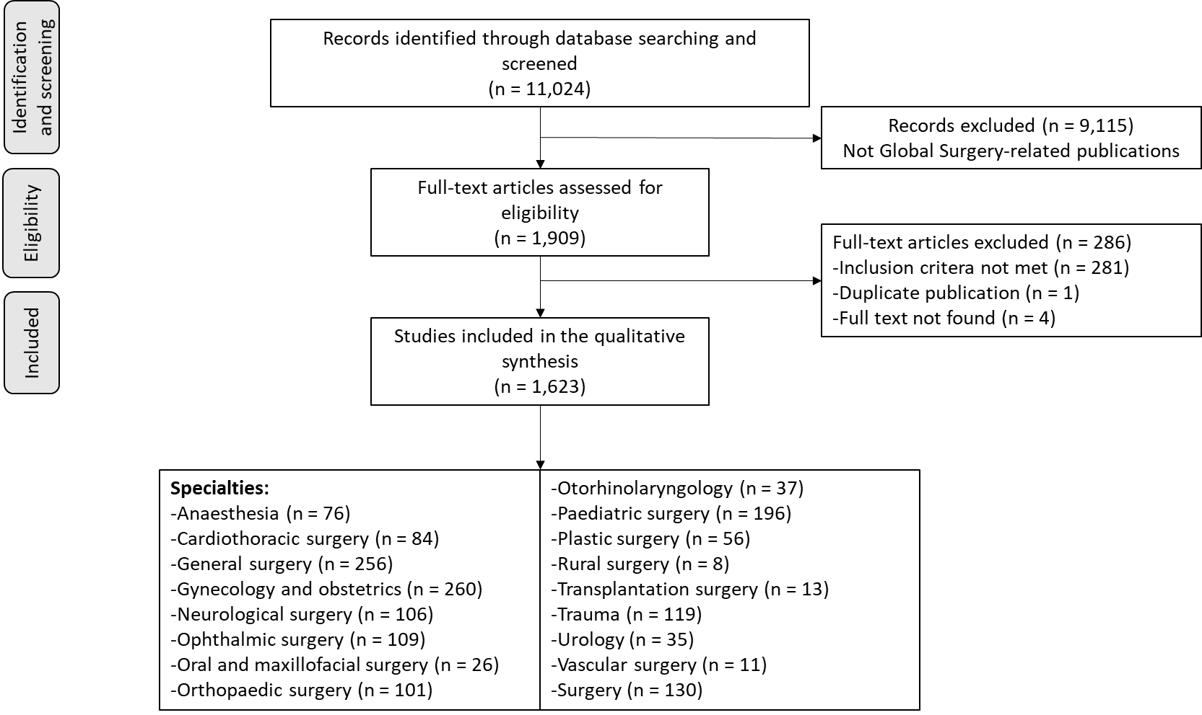

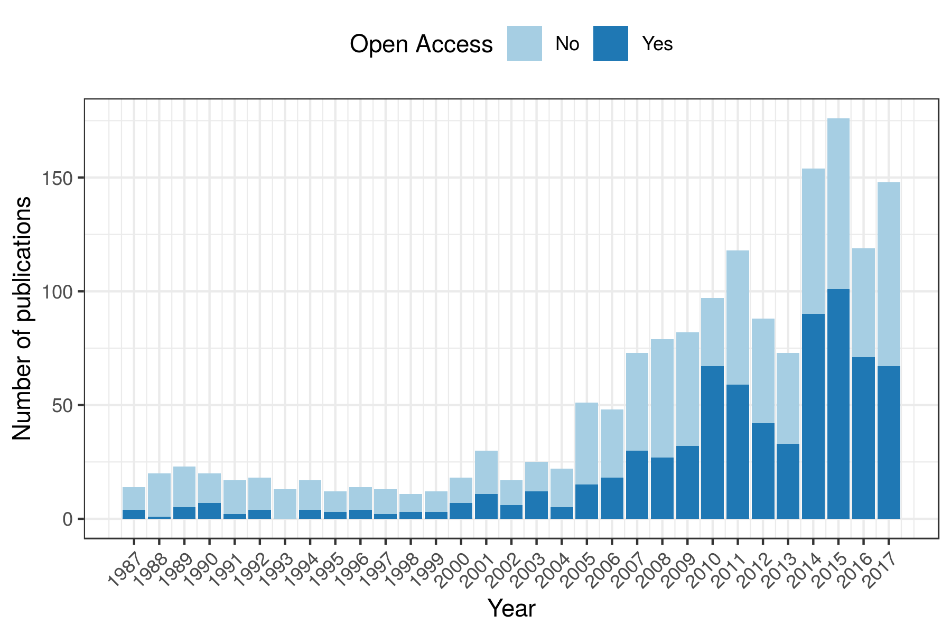
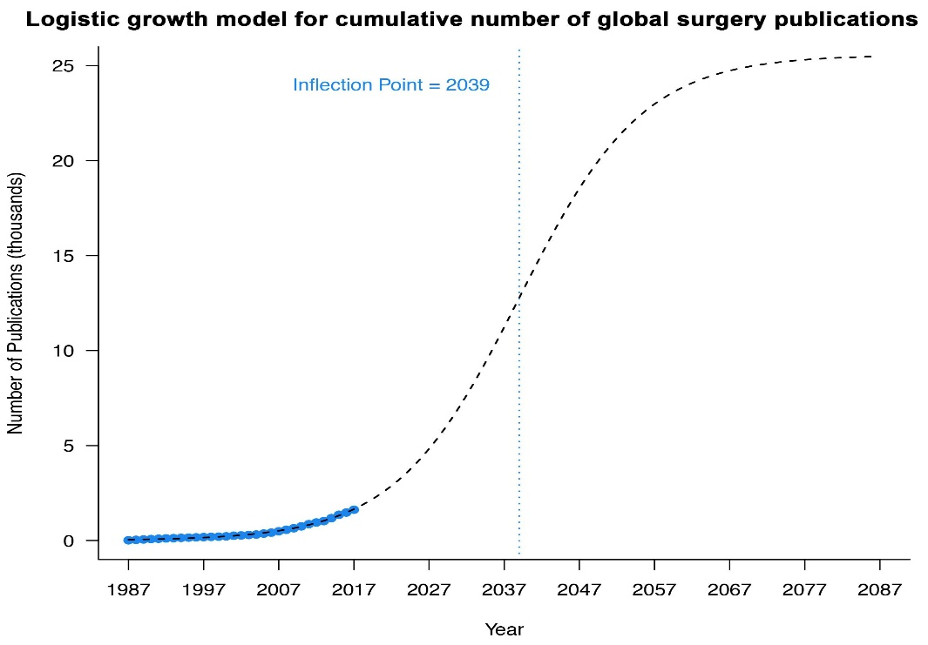
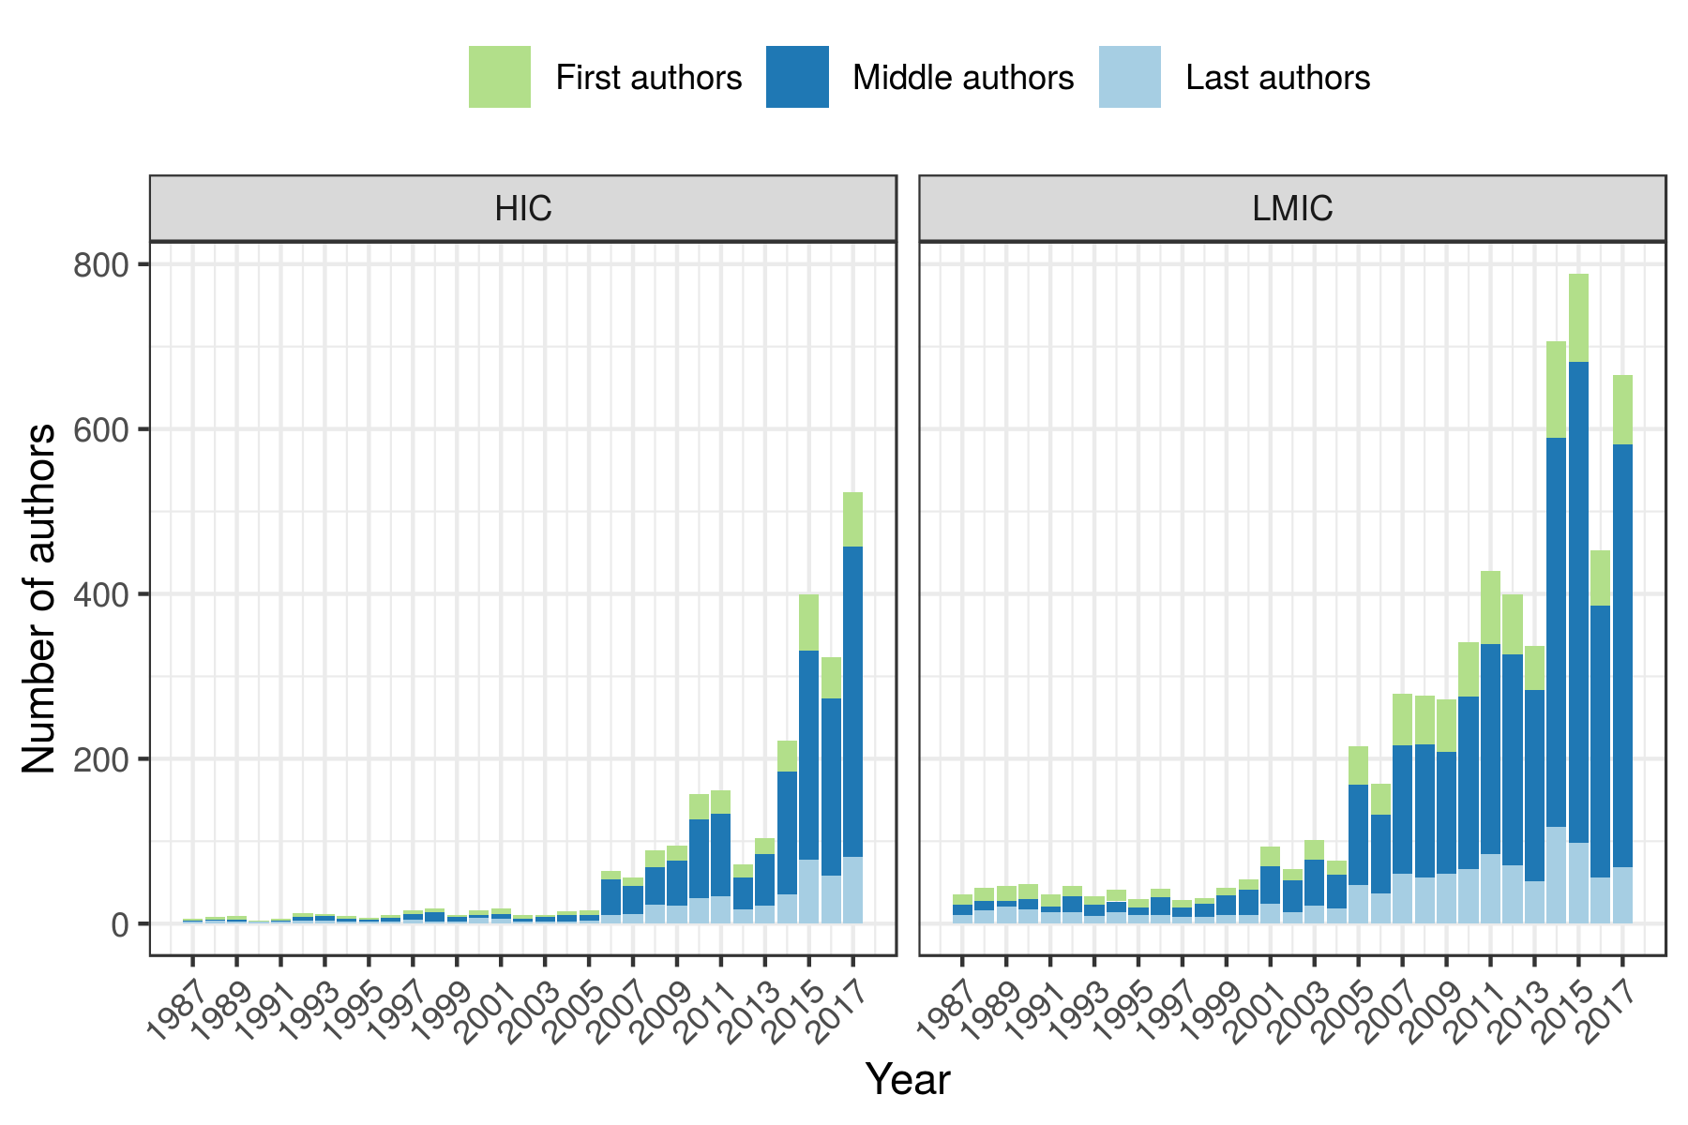
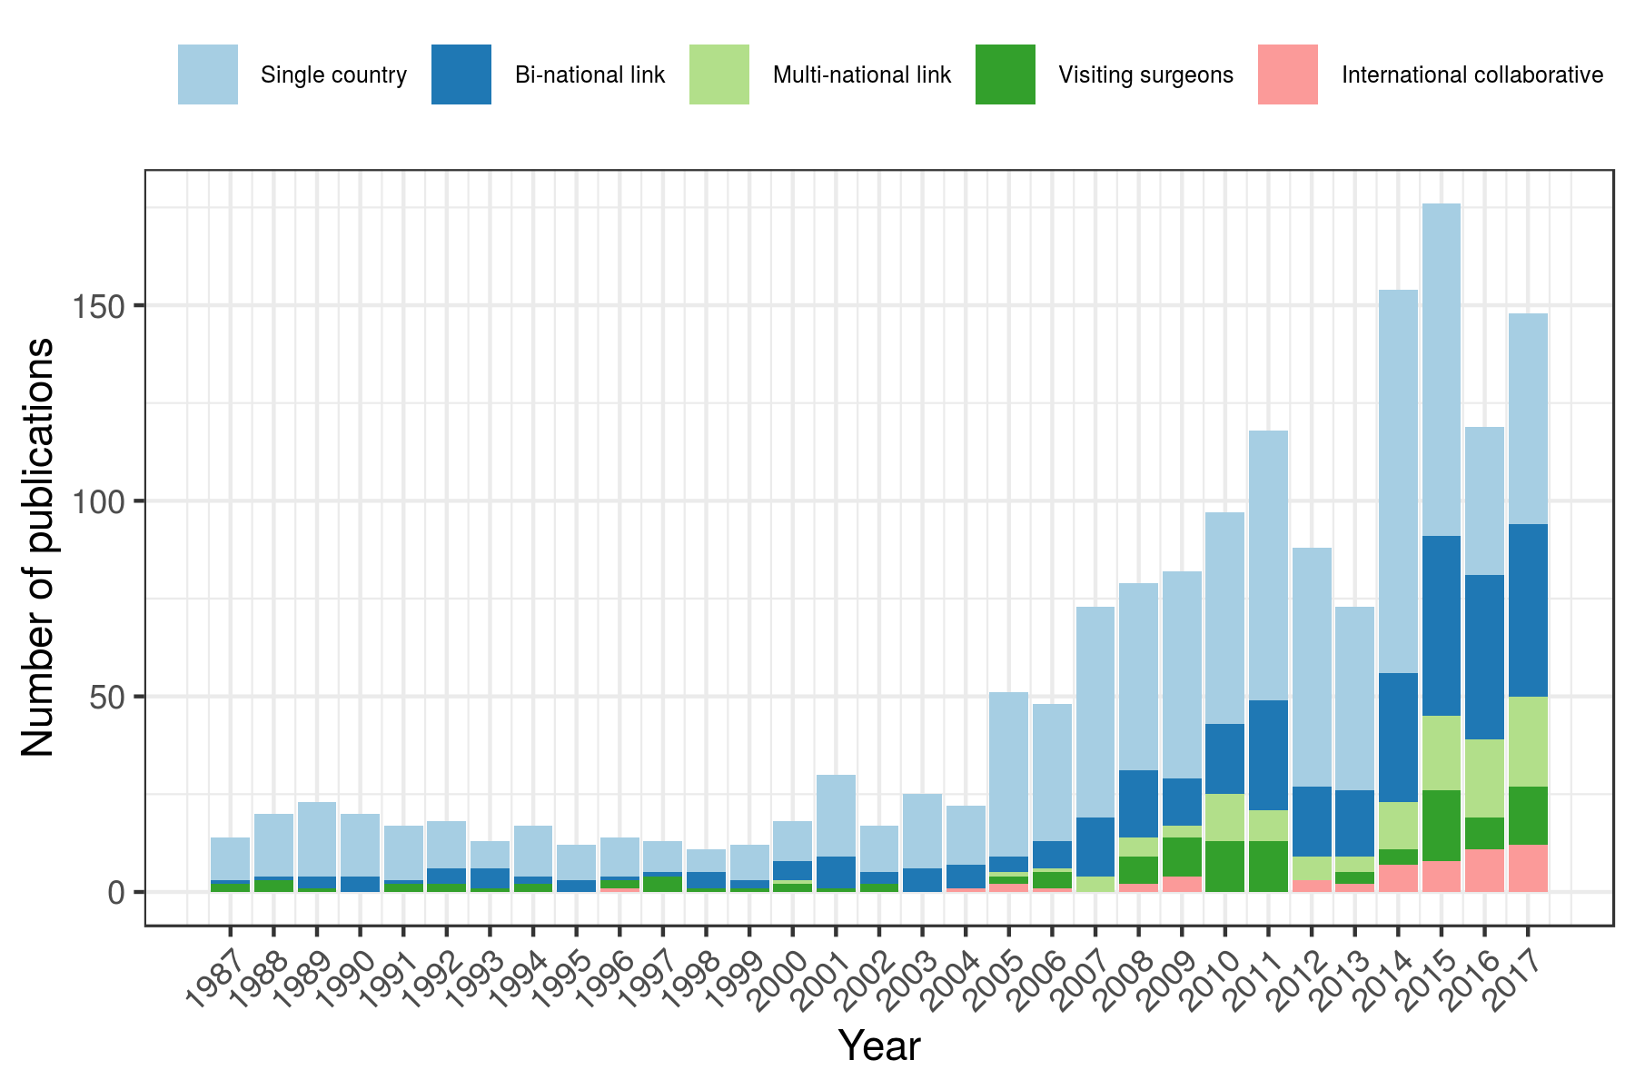
Figure 2
A
B
C
D
Figure 3

